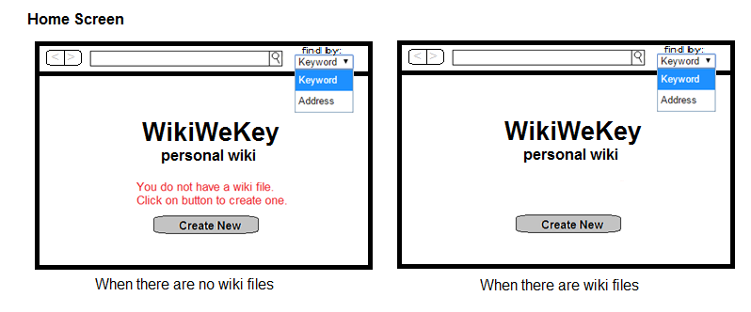

* History arrows on upper left, like a web browser. They are grayed out and un-clickable if there is no page backwards or forwards (respectively) in history.
* Search is either by keywords or address (which is the full file path). This is chosen by a dropdown menu. Hitting return or the magnifying glass initiates search.
* If there are no files or folders in the wiki directory it prompts you to create a new wiki page (red text).
* Create New button takes one to the edit(create) screen. One can start a new wiki at any time as this button appears on each page

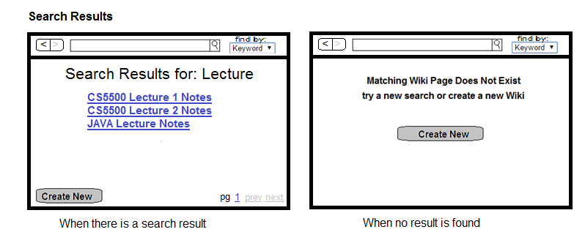

* If searching by keywords it displays all wiki pages that contain the given key words in the title (aka file name).
* If searching by address it directly pulls up read(view) page [shown below].
* Titles are displayed in hyperlink format and can be clicked to take one to the read(view) page
* It will display around 10 results (or whatever reasonably fits on one screen) per search page.
* Additional pages are shown in hyperlink format on the bottom right corner as well as prev and next buttons, which take to the previous and next page respectively. If there are no pages before or after the current page the buttons are grayed out.
* If the search fails to find matching wiki pages a message appears prompting one to try a new search or create a new page along with the create new button.

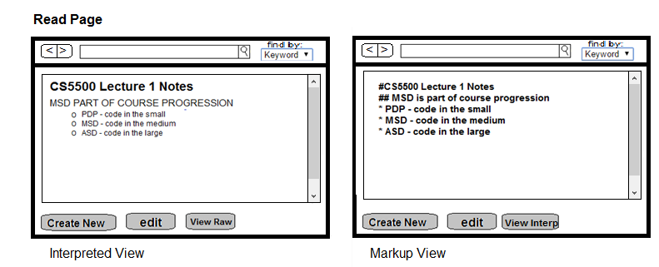

* Read page appears by either directly typing in the address or by clicking on a search result
* The default view is the rendered page, but a view raw button allows one to see the markup text
* When viewing the markup text one can click the view interp button to go back to the rendered view.
* Note user cannot make any changes to document in either view. They must hit edit to do so.
* The edit button takes one to the edit screen and it can be accessed by either the raw or interpreted views.
* A scroll bar allows for viewing the entire page in one screen when the text otherwise doesn’t fit.

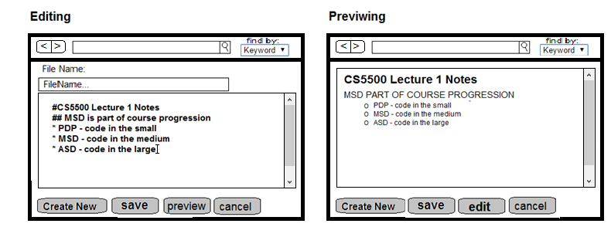

* From the read screen or create new button one can enter the edit screen (the only difference being that the editor is empty for create new, while for edit it displays the current markup text).
* File Name will display the current title of the wiki page (its blank when creating a new wiki page). One can type into this box to change the file name.
* One can directly type in the wiki markup language in the box below.
* Hitting preview allows one to see what the text looks when rendered
* Hitting edit from the preview screen allows one to continue editing the text
* Advanced Feature for a later date: once we have this implementation working we would like to have a split screen button that allows one to view a split screen when editing where the left screen is the editing window and the right is a live preview window
* From either screen one can save or cancel. Cancel removes any unsaved changes and returns to the interpreted view.
* When saving changing the file name changes its title and replaces the old file. When creating a new page it creates a new file with the given name. In either case if the name already exists it prompts the user to choose another name (or overwrite).
* If one leaves the edit screen without saving a message should appear asking if they would like to save changes.

Additional Notes:

* We want the program window to be resizable. By default it should take up approximately 2/3rd of the screen with a similar aspect ratio as the full screen.